10-17-2018
log transformation and FDR 0.05 CpGs
Guannan Shen
ECCHO

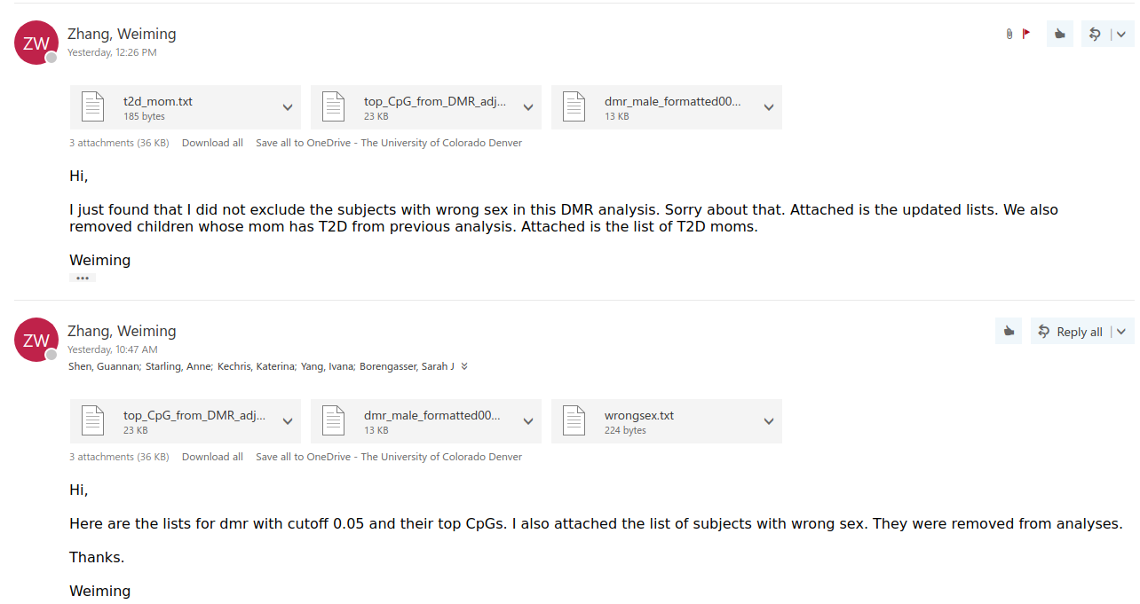

Dataset updated

Data Pre-processing
Male 305 subjects
Female 278 subjects
## [1] 583 320
## [1] 305 320
## [1] 278 320
## [1] "cg16884940"
## [1] "cg16884940 are not in the TOP300 M values CpG list"
## [1] 583 140
## [1] "now the CpGs are 120 and whole sample size is 583"
## [1] 305 140
## [1] 278 140

cpg_reg <- function(outcome, data, name, Topn, Gender, ncpg) {
## outcome lm
outcome_lm = lapply(21:(ncpg + 20), function(i) {
lm = lm(outcome ~ data[, i] + maternal_age + race_4 +
Bcell + CD4T + CD8T + Gran + Mono + NK + nRBC, data = data)
coef = round(summary(lm)$coefficients[2, ], 4)
return(coef)
})
outcome_lm = data.frame(matrix(unlist(outcome_lm), ncol = 4,
byrow = TRUE, dimnames = list(c(colnames(data)[21:(ncpg +
20)]), c("Estimate", "Std.Error", "t.statistic",
"p.value"))))
# adjusted p-value
outcome_lm = outcome_lm %>% mutate(FDR = p.adjust(p.value,
"BH", ncpg), names = colnames(data)[21:(ncpg + 20)]) %>%
select(names, everything())
# sort by p.value
outcome_lm = outcome_lm[order(outcome_lm$p.value), ]
## sample size
size = length(outcome) - sum(is.na(outcome))
## summary table
kable(head(outcome_lm, Topn), caption = paste("Top10 CpGs from ",
ncpg, " for ", name, " of ", Gender, " by p.value", " (Sample Size = ",
size, ") ", sep = "", collapse = ""))
}

Test normality of Outcomes
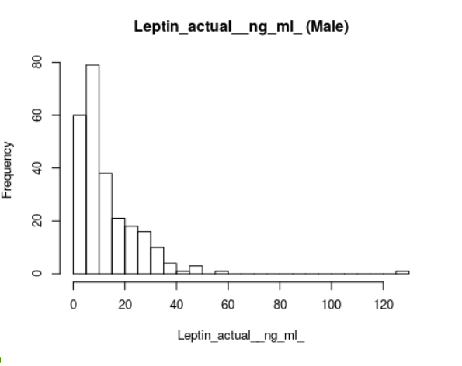
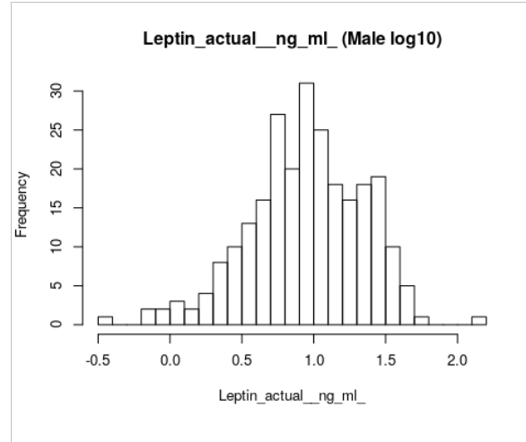
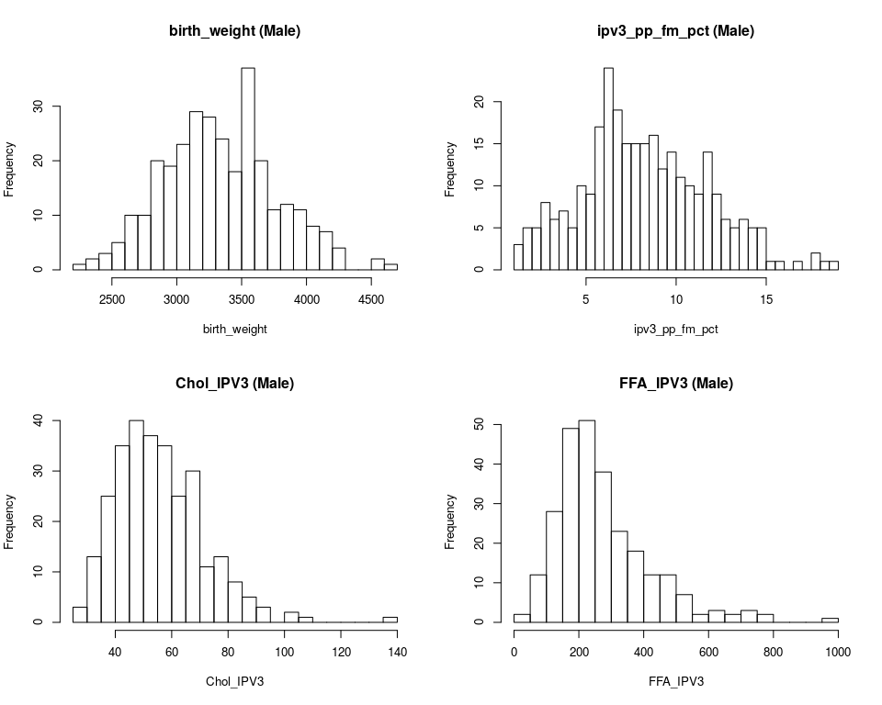

May
not

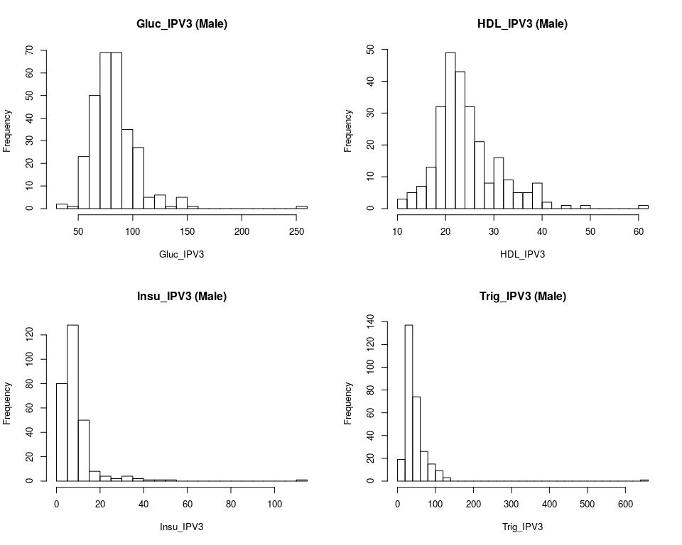

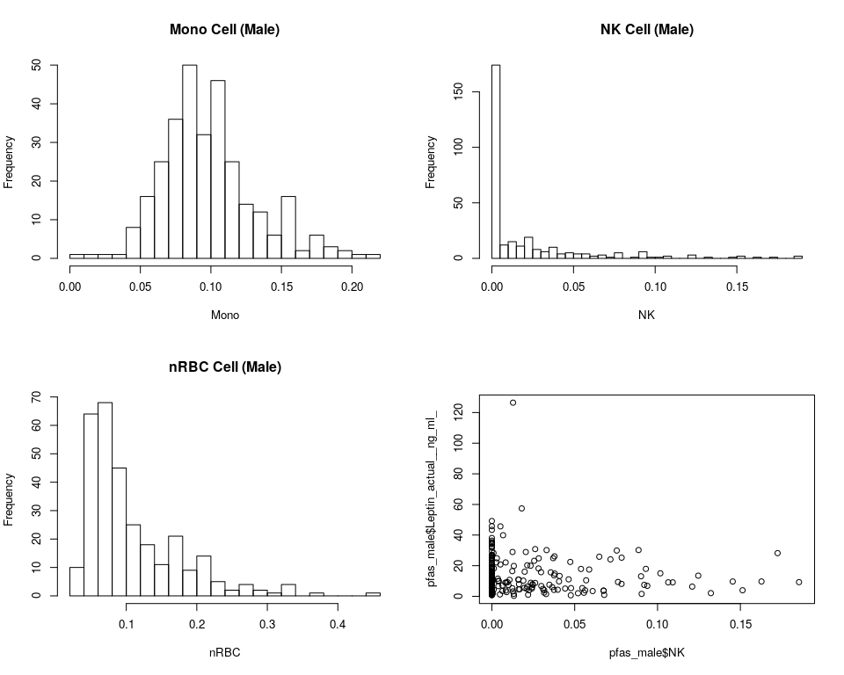

Results
Tables
1 - 9 Male TOP300 CpGs
10 – 18 Male TOP300 CpGs log10
19 – 27 Female TOP300 CpGs log10
28 – 36 Male (TOP300 and FDR 0.05) 120 CpGs log 10
37 – 45 Female (TOP300 and FDR 0.05) 120 CpGs log 10

